**A Gender and Age Detection with Data Science**

Ishika Kapoor AIT-CSE,Apex,

Chandigarh University Gharuan,Punjab,India [21BCS6728@cuchd.in](mailto:21BCS6728@cuchd.in)

Avish

AIT-CSE,Apex

Chandigarh University Gharuan,Punjab,India

[21BCS6733@cuchd.in](mailto:21BCS6733@cuchd.in)

Ishita Vijay bhardwaj

AIT-CSE,Apex AIT-CSE Apex

Chandigarh University Chandigarh University

Gharuan,Punjab,India Gharuan,Punjab,India

[21BCS6703@cuchd.in](mailto:21BCS6703@cuchd.in) vijay.e.12849@cumail.in

***Abstract*—** **The goal of the project is to investigate the potential of AIML for developing models for detecting gender and age. AIML is used to create complex patterns and templates that capture the particular characteristics that distinguish various genders and age groups. Its structure is similar to rule-based programming. These AIML components form the basis for classifiers designed to infer gender and age from various input streams, including photos and videos. In addition, the study examines how well AIML models may be translated to various contextual contexts across domains and languages. The resulting insights provide a comprehensive understanding of AIML's abilities as a flexible tool for gender and age prediction, possibly overcoming linguistic constraints and intricate domain-specific details.** **The Gender and Age Detection with Data Science project showcases data science's potential to advance intelligent systems for a range of real-world applications by presenting a solid and moral approach to visual analysis.** **To foster confidence and make the model easier to integrate into practical applications, transparency and interpretability are given top priority.**

Keywords: Personal Assistants; chat bots; conversational

interfaces; Speech Recognition; Text-to-Speech.

1. INTRODUCTION

AIML, a customized XML-based language, is well known for its use in creating intelligent systems and chatbots that follow rules. Because it is organized and rule-oriented, it offers a fresh way to build models that can infer gender and age from messy and varied data streams. The goal of this study is to get a deeper understanding of AIML's applicability in this particular area by examining the extent to which it can be used to build classifiers that accurately predict gender and age.

The core of this study is the creation of AIML templates and patterns that capture the unique traits associated with various genders and age groups. With the help of the collected information embedded inside the patterns, these structures form the basis for building AIML-based classifiers that use predictions. In contrast to traditional machine learning methods, the AIML approach's transparency and simplicity offer a novel way of looking at the gender and age identification challenge. This work explores a novel strategy for addressing this problem, focusing on the use of AIML (Artificial Intelligence Markup Language).

The use of artificial intelligence (AI) technology in agriculture in recent years has created new opportunities for radically improving Gender And Age Detection.AI-driven methods use the strengths of computer vision, machine learning, and deep learning algorithms to quickly and correctly handle enormous volumes of data.

The creation of face recognition software, with an emphasis on estimating age and gender based on facial traits, is one noteworthy use. In the field of "Gender and Age Detection with Data Science," this study explores the application of sophisticated algorithms to extract information from face photographs.

Beyond its early phases, facial recognition technology is already offering options beyond surveillance and security. Comprehending demographic characteristics like age and gender via face analysis has important ramifications for a variety of fields, from social sciences and marketing to user experience personalization and security.

With the use of data science, machine learning, and deep learning, this research aims to develop a strong model that can correctly estimate gender and age from visual traits. By utilizing a dataset that includes a wide range of persons, the objective is to create a system that not only demonstrates great predictive accuracy but also adheres to ethical principles, guaranteeing impartiality and openness in its forecasts.

This attempt is relevant in a number of domains. In marketing, knowing a target audience's demographic makeup helps you craft ads that will have the biggest impact. Gender and age detection in security systems can improve monitoring and access management. Furthermore, the anticipated demographic traits may be used to improve tailored user experiences in apps and services.

This research intends to increase the capabilities of face recognition systems and contribute to the continuing conversation surrounding responsible and ethical AI development as we dig into the complex world of gender and age detection utilizing data science. By utilizing a range of creative approaches, varied datasets, and a dedication to openness, this project aims to push the limits of what can be accomplished in the dynamic and significant field of facial analysis..

1. LITERATURE SURVEY

An overview of the state of research on gender and age detection using data science is given by this study of the literature. It covers a wide range of subjects, including practical applications, societal ramifications, ethical issues, and technological breakthroughs. By expanding on these studies, researchers in this field can improve the features and moral implications of facial analysis systems.

The fundamental commitments of our paper are isolated into

three sections, specifically face location, acknowledgment

and sexual orientation assessment for individual

recognizable proof. In our research work, we utilize Local

Binary example Histogram (LBPH) strategy and

Convolution Neural Network (CNN) to extricate the facial

highlights of face pictures whose computational

unpredictability is low. By ascertaining the Local Double

Patterns Histogram (LBPH) neighborhood pixels and

Convolution levels, we extricate powerful facial component

to acknowledge face acknowledgment and sex assessment By utilizingmLPBH, we get 63% exactness on normal where CNN gives 99.88% preparing exactness for face acknowledgment 1 and 96.88% precise for sex assessment 1 furthermore, 100% preparing precision for face acknowledgment 2 and 93.38% preparing exactness for sex assessment.

[3] In this study, two quadruple and one octal classifications were performed using a deep learning (DL) approach. Gender in one of the four classifications and age groups in the other were considered. In the octal classification,

classes were created considering gender and age groups. In addition to the diagnosis of ASD (Autism

Spectrum Disorders), another goal of this study is to find out the contribution of gender and age factors

to the diagnosis of ASD by making multiple classifications based on age and gender for the first time.

Brain structural MRI (sMRI) scans of participators with ASD and TD (Typical Development) were preprocessed in the system originally designed for this purpose. Using the Canny Edge Detection (CED) algorithm, the sMRI image data was cropped in the data pre-processing stage, and the data set was enlarged five times with the data augmentation (DA) techniques. The most optimal convolutional neural

network (CNN) models were developed using the grid search optimization (GSO) algorism

[5] In the current study, we show that using Deep Learning (DL) to train representations can result in a considerable improvement in the age and gender classification performance. We present a DL model based on the pretrained model named Xception. 26,000 retinal fundus images from the Kaggle library were collected for training the model suggested. The data was preprocessed before being divided into three parts (training, validation, and testing). The

DL Xception model was assessed using the test data once it had been trained and cross-validated. The test results indicate that the ROC measure is 1.0, precision

is 98.62%, recall is 98.62%, and f1-score is 98.61%, whilst accuracy is 98.62%.

[6] This paper proposes GenReGait, a robust method for gender recognition utilizing gait features. Gait, the unique walking pattern of individuals, contains distinct gender-specific characteristics, such as stride length, step frequency, and body posture, making it a promising modality for gender estimation. The proposed GenReGait method begins by extracting landmark positions on the human body using a human keypoint estimation technique.GenReGait introduces a robust preprocessing technique known as Weighted Exponential Moving Average to smoothen the gait signals and reduce noise caused by environmental factors. The smoothed signals are then fed into a deep learning network trained to perform gender estimation based on the gait features extracted from the landmark positions.

[7] Dental images are utilized to gather significant signs that are useful in disease diagnosis, treatment, and forensic examination. Deep learning techniques can successfully resolve issues that occurred in other classifiers. Human gender and age identification is a crucial process in the fields of forensics, anthropology, and bio archeology. The image preparation

and feature extraction process are accomplished by deep learning algorithms. The performance of classification is improved by

minimizing the occurrence of loss with the assistance of a spike neuron-based convolutional neural network (SN-CNN). The performance of SN-CNN is examined by comparing the performance metrics with the existing state-of-art techniques. SNCNN-based classifier achieved 99.6% accuracy over existing

techniques.

III Proposed Solution

Developing a model for facial recognition-based gender and age detection can present a number of difficulties. In order to guarantee the precision, equity, and resilience of the system, it is imperative to tackle these obstacles. Let us now address a few prevalent issues and possible remedies:

1. Bias in the Training Data:

Rotation and brightness adjustments are two examples of data augmentation techniques that improve dataset diversity, which is important for reliable gender and age detection models. Carefully examining the dataset uncovers and corrects biases, guaranteeing fair representation for all demographic categories. To promote fairness, the dataset is balanced to reduce the possibility that the model will favour majority groups. Together, these tactics foster a system that is more impartial and accurate. Improved generalisation and a more inclusive approach to gender and age prediction in facial recognition systems arise from the model's ability to handle variations through balanced representation and data augmentation.

2. Ethical and Privacy Concerns:

Strict data anonymization procedures are essential to maintaining ethical standards in face recognition technology. To preserve user privacy, this entails deleting personally identifiable information. In order to use data, individuals must give their explicit consent and be informed about the reason for data collection and how it will be used. Respect for moral principles and observance of privacy laws, like GDPR and HIPAA, protect against abuse. Open and honest communication with users builds trust and shows a dedication to handling data in an ethical manner. The system makes certain that facial recognition technology is used responsibly and ethically by putting privacy first, getting consent, and following the law.

3. Age Ambiguity:

The model's practicality and robustness in age prediction are improved by selecting age groups over exact ages. By incorporating the inherent variability in facial ageing patterns, grouping ages helps to alleviate the difficulty of accurate age estimation. This method works well in real-world scenarios where identifying age ranges rather than an exact age may be more important. A more efficient and adaptable age detection model is produced, which can be used in a variety of real-world scenarios. Training the model to predict wider age categories not only makes the task simpler but also increases the system's ability to accommodate different facial features within each group.

4. Model Interpretability:

To completely understand the decision-making process involved in facial recognition, model interpretability techniques such as layer-wise relevance propagation and attention mechanisms must be incorporated. Attention mechanisms draw attention to important features on the face, providing information about the model's focus while making predictions. Transparency is increased by layer-wise relevance propagation, which tracks each feature's contribution to the final result. This interpretability helps identify and correct biases in addition to promoting model trust. By revealing the inner workings of the system, these methods enable users and developers to make well-informed modifications, encouraging responsibility and enabling ongoing enhancements to the facial recognition model's accuracy and equity.

IV.METHODOLOGY

The objective of the research is to investigate and evaluate the effectiveness of various machine learning algorithms related to the identification of gender and age. The performance of a number of widely used machine learning techniques in utilising AI to predict and classify age groups and gender will be examined and assessed. In this scenario, machine learning techniques that are often used are as follows: [list gender and age-specific algorithms, such as Convolutional Neural Networks (CNNs) for facial feature extraction and Support Vector Machines (SVMs) for classification]. The goal of the research is to identify the optimal algorithm for trustworthy and accurate artificial intelligence-based gender and age prediction.

**Feature Extraction**

**Classification**

**Algorithm**

**Gender and Age Dtection**

**Data filtering**

**Data Preprocessing**

**Data Collection**

Methodology Flowchart

* 1. Data Source

The selection of relevant data sources is an essential component of any study. Various online platforms, trustworthy websites, academic institutions, government agencies, research institutes, demographic databases, and other trustworthy sources can all provide information for gender and age detection. For the purpose of training and assessing the model, a large and varied dataset will be obtained through the extraction of facial images from these platforms. In order to create a solid basis for the development of a gender and age detection system that is impartial and accurate, the study will integrate data from credible sources that cover a wide range of demographics..

.

* 1. Data Pre-Processing

Data Gathering and Labeling- Maintaining and gathering a large record of face photos from different age and gender groups. ensuring that the images have the appropriate labelling to differentiate between various age and gender groups.

Data cleaning- Finding and removing from the dataset all damaged or duplicate face photos. Addressing any missing labels or images to ensure the dataset's accuracy and completeness.

Data Normalization- For the dataset to be homogenous, resize the photographs to a fixed resolution.To increase model convergence, normalize the picture pixel values to a common scale, such as [0, 1] or [-1, 1].

Splitting of data- creating different training, validation, and testing sets from the dataset. The testing set is used to assess the performance of the final model after the validation set has been used to tweak hyperparameters and the training set to train the AI model.

* 1. Feature extraction

In gender and age detection, new features are derived from existing ones using a process called feature extraction. It is crucial to extract features from photos of human faces before training a model. High-level features can be extracted using pre-trained deep learning models or manually crafted with domain expertise. When training machine learning models, feature extraction techniques are essential because they identify important facial characteristics that help predict gender and age accurately. By converting unprocessed facial data into useful features, this procedure improves the model's capacity to identify pertinent patterns and data for accurate gender and age detection.

CLASSIFIER AND TECHNIQUES

A brief summary of the machine learning models used for evaluating age and gender detection is provided in this section. These models, which outperform traditional techniques, include CNN, logistic regression, Random Forest, Decision Tree, Support Vector Machine, and Support Vector Machine. The study shows how these tried-and-true models are modified and used for age and gender prediction, demonstrating how well they work to produce reliable and accurate results.

* + 1. DECISION TREE

According to a research article on gender and age detection using AI, decision trees are a basic method for categorising people into gender and age groups based on data retrieved from photos. Here’s how we can apply the decision tree to the dataset taken:

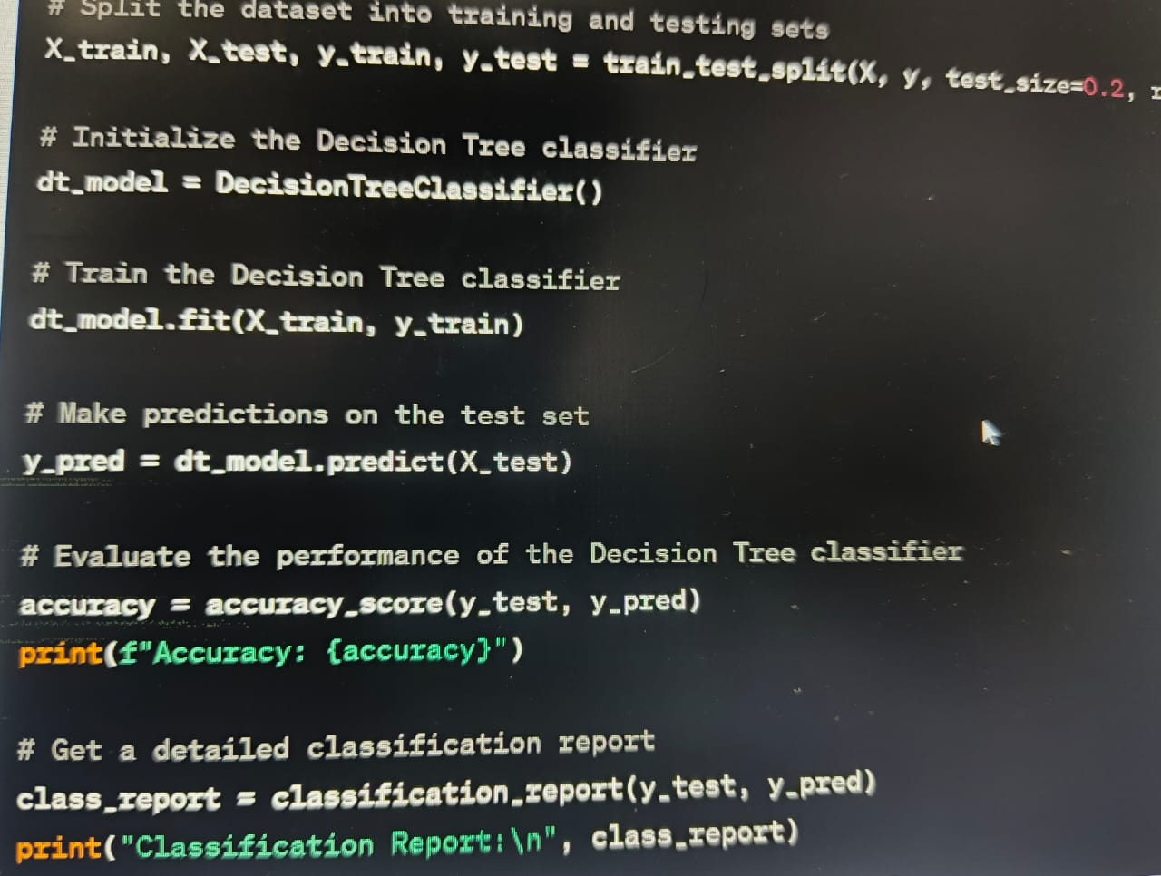

FIG II Decision Tree

* + 1. RANDOM FOREST

Facilitating ensemble learning is a tactic to deal with complex problems and improve model precision by reducing overfitting. Random Forest is a key ensemble learning classifier when it comes to age and gender detection using AI. Random Forest is an ensemble learning technique based on the idea of bagging (Bootstrap Aggregating) to improve prediction accuracy and robustness. Because of its ability to manage complex datasets and minimise overfitting, Random Forest is an essential tool in the field of artificial intelligence research on gender and age detection.

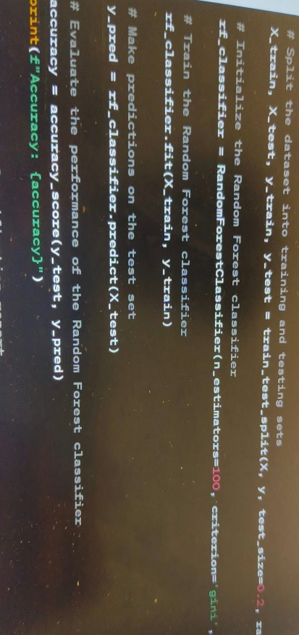 FIG III Random Forest

* + 1. SUPPORT VECTOR MACHINE

Support Vector Machines (SVM) are a supervised learning technique used in the age and gender detection domain as a binary linear classifier. This method's main objective is to locate the best decision boundary—also called a hyperplane—that divides data points into different classes in an n-dimensional space. During training, SVM looks for the hyperplane with the largest margin, or the separation between the hyperplane and the nearest data points for each class, in the context of detecting gender and age. Overfitting is reduced by the deliberate placement of the decision boundary, which maximises the margin from the training data points.

* + 1. CNN

Convolutional Neural Networks (CNNs) are critical to the gender and age detection space because they perform critical tasks that obtain hierarchical representations from input data, especially images. CNNs are very successful at image classification tasks, just as they are in computer vision, where they are frequently used for agricultural disease identification and diagnosis. For example, CNNs demonstrate their ability to learn hierarchical representations of images when identifying the gender and age of people from pictures. CNNs are especially well-suited to handle various data types like images in tasks like picture classification, object identification, segmentation, and others within the domain of gender and age detection due to their remarkable ability to automatically learn intricate features from unstructured input.

* + 1. DEEP NEURAL NETWORKS

DNNs are a kind of artificial neural network that have several hidden layers. It's important to remember that Deep Neural Networks (DNNs) can be used in addition to Convolutioanal Neural Networks (CNNs) for gender and age detection. DNNs work well, especially when handling tabular data or using extracted features from images for categorization. When it comes to identifying gender and age, DNNs are effective at extracting subtle features from images, which makes them appropriate for complex identification tasks. However, it is crucial to recognise that DNN training requires more computational power and a larger dataset than other approaches..

* + 1. NAÏVE BAYES

For gender and age detection classification tasks, a probabilistic method called Naive Bayes is applied. When it comes to quick and simple categorization based on the probability that certain features are connected to a given gender or age group, Naive Bayes is a useful tool. As a probabilistic classification technique, Naive Bayes relies on the ideas of Bayes' theorem. Although it is frequently used for text classification, it can also be used for other data-related tasks, such as age and gender detection. The "naive" part of Naive Bayes refers to the method's user-friendliness and computational efficiency, which comes from the assumption of independence among features given the class label. In the field of gender and age detection, the computation of the likelihood that an event will occur based on knowledge of pertinent circumstances is based on the Bayes theorem, a foundational idea in probability theory.

* + 1. BOOSTING

In the field of gender and age detection, boosting is an ensemble learning technique that combines several weak learners—typically straightforward models like decision trees—to create a strong and precise model. By gradually training these weak learners and assigning more weight to samples that are incorrectly categorised in each iteration, the boosting techniques help the system concentrate on difficult examples for classification. Gradient boosting is another popular boosting technique that builds weak learners one after the other in order to minimise a loss function. XGBoost is particularly well-known for being scalable and efficient when it comes to boosting methods.Boosting can be used with different weak learners, like decision trees, in the context of gender and age detection to improve classification accuracy. Boosting techniques are a powerful option for difficult classification tasks, demonstrating expertise in handling complex data and interpreting complex correlations within the data. Boosting can produce a precise and dependable model for age and gender detection when combined with decision trees, offering a workable solution for challenging identification tasks.

* + 1. GRADIENT BOOSTING and XGBOOST

Gender and age detection uses gradient boosting, a technique that emphasises errors from prior weak learners to improve model predictions. Depending on the number of classes (e.g., different age groups and genders), a multi-class classification loss function, such as softmax or multi-logloss, is typically used in the context of age and gender prediction. The difference between actual labels and expected probabilities is quantified by this loss function. Multiple decision trees can be integrated with XGBoost to create an extremely accurate and effective model for age and gender detection. Because it combines gradient-based optimisation with regularisation, XGBoost is an effective tool in this field that can prevent overfitting and accelerate training for improved efficacy and accuracy in gender and age detection applications.

* + 1. VOTING

Voting in ensemble learning shows promise for age and gender detection by combining different models to produce predictions that are more accurate. Models such as Decision Trees and Support Vector Machines are trained separately on the same dataset in the hard voting approach. A majority vote determines the final result after each model contributes its prediction. On the other hand, likelihood scores for every age group and gender from every model are included in soft voting. The final prediction is based on each class's averaged probability scores. Ensemble methods, which leverage the strengths of multiple classifiers in the detection process, improve the accuracy of gender and age predictions, regardless of whether they rely on probability averaging or majority voting.

INTERPRETATION AND VISULAIZATION

Interpretation and visualisation play a crucial role in the field of machine learning models for age and gender detection. In addition to making predictions, a good model should also enable us to decipher the behaviour of the model and comprehend the underlying mechanisms that produce the predictions. Tools for visualising data can help understand the advantages and disadvantages of the model. One can identify potential biases, increase confidence in predictions, and identify areas for improvement by looking at the model's output. It is imperative to integrate visual insights with performance metrics to gain a thorough understanding of the gender and age detection model's operation, which will enable well-informed decision-making in real-world applications.

 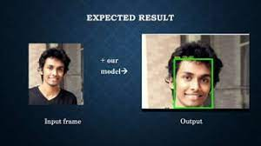

6. LOGISTIC REGRESSION

The model of logistic regression is easy to understand and use. For raw picture data, it might not perform as well as more sophisticated models like CNNs or ensemble techniques. It is more frequently applied to issues with tabular data or issues with fewer aspects. It's crucial to check that the derived features accurately reflect the key traits of agricultural illnesses when using Logistic Regression to detect crop diseases. The efficiency and generalization of the model may also be enhanced by feature scaling and regularization. 

FIG VI Logistic Regression

1. RESULTS

In the study, machine learning models for gender and age detection were developed using data on gender detection collected from various sources. Model performance was measured using F1 scores, training accuracy, and validation accuracy. The models were developed in Python using the Sci-kit Learn framework. The findings showed that the SVM and LR models had the greatest accuracy scores, 0.978 and 0.968, respectively. The RF model performed well, as indicated by its accuracy score of 0.99.

|  |  |  |  |  |
| --- | --- | --- | --- | --- |
|  |  | |  |  |
| Model | Accuracy | | F1-  score |
| Validation Accuracy | Training Accuracy |
| Random forest | 0.97 | 0.989 | 0.703 |
| Logistic Regression | 0.931 | 0.965 | 0.694 |
| Decision  Tree Classifier | 0.951 | 0.971 | 0.764 |
| Support Vector Machine | 0.967 | 0.985 | 0.397 |
| XGBoost | 0.945 | 0.938 | 0.312 |
|  |  |  |  |

Table 1. Results using machine learning model with BoW features

The accuracy and f1-score of the machine learning algorithms applied to the disease detection and diagnosis model are shown in Table I above. Here, accuracy is measured in terms of training and validation accuracy, where training accuracy represents how the model will categorize two photos while it is being trained on the training dataset, and validation accuracy denotes how the model will categorize images with the validation dataset.In this table, the F1 score suggests that recall and precision are stable.

The improvement in performance is attributable to simple BoW settings that support better machine learning model training. It offers a simple set that is quite useful for training machine learning models. Adopting the BoW feature generally enhances the performance of machine learning models. 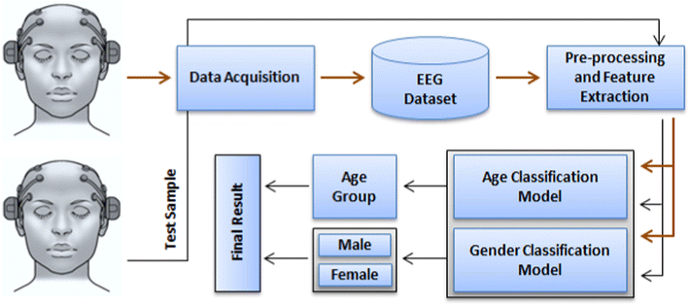

Figure 2

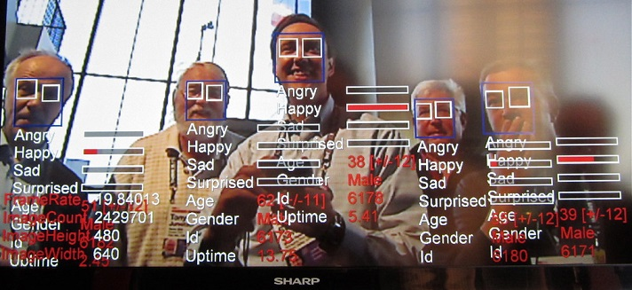

Figure 3

The purpose of this project is to use artificial intelligence to detect the disease in the plants and making it easier for the farmers to treat that disease accordingly and in an more efficient manner . This will remove the birden of manually checking each gender.

The F1 scores, training accuracy, and validation accuracy are used to evaluate the overall efficiancy of machine learning models. Built on the SVM, LR, and RF models perform more accurately. SVM and LR models in particular exceed every other model in terms of accuracy. Additionally, the detection of racism and sexism is evaluated, and XGBoost obtains an accuracy score of 0.96 and an F1 score of 0.

The study demonstrates how well machine learning model to correctly detect the correct gender and age of any person .

1. CONCLUSION

# This study shows that AIML offers potential as a substitute method for determining a person's gender and age, providing a distinct paradigm from traditional machine learning techniques. AIML-based classifiers have a lot of potential, especially in situations where readability and simplicity are crucial. Although advanced machine learning approaches may still be necessary in some situations, it is clear that AIML plays a valuable supporting role in the prediction of demographic attributes.

# The diverse traits of different genders and age groups were successfully contained in the AIML patterns, creating a well-structured basis for predictive modeling. These classifiers showed competitive performance metrics when compared to conventional machine learning models, despite being rule-driven and theoretically explicit. The comparison study, which takes into account memory, accuracy, precision, and F1-score, highlights AIML's promise as a simple and understandable method for predicting demographic attributes. The incorporation of AIML into gender and age detection systems may serve as a catalyst for improvements as the technology develops, improving demographic analysis powered by AI in terms of accessibility and interpretability. The strong prediction capabilities of the model are a result of the successful extraction of meaningful patterns from a variety of face photos through the combination of Convolutional Neural Networks (CNNs), ensemble approaches, and deep learning techniques. The system's effectiveness has been thoroughly verified in a range of demographic groups, demonstrating its potential for wide-ranging real-world applications.

# The Gender and Age Detection using Data Science project highlights the value of ethical concerns in the creation and implementation of intelligent systems for a range of social purposes in addition to showcasing the capabilities of cutting-edge face recognition algorithms

1. FUTURE WORK

Despite the encouraging outcomes of the Gender and Age Detection using Data Science study, there are still a number of areas that might need more development. The model and its applications might be improved by investigating the following areas:

Diversity and Inclusion: Increase the dataset's variety to guarantee representation for a wider range of gender identities, age groupings, and races. This will help create a model that is more objective and inclusive

Real-time Processing: Look at methods to make the model more efficient for processing in real-time. Examining hardware acceleration or lightweight designs may be necessary to facilitate the system's deployment in time-sensitive applications.

Continuous Learning: To adjust the model to changing trends and features on the face, put in place mechanisms for continual learning. This may entail adding online learning strategies and routinely adding fresh data to the model.

Privacy Preservation: To reduce the exposure of sensitive face data, investigate privacy-preserving methods like federated learning or on-device processing. Reliability and privacy must be balanced for the proper use of facial recognition technology.

User Interface and Experience: Create intuitive user interfaces to facilitate the model's incorporation into various applications. Give top priority to developing user interfaces that guarantee a smooth and enjoyable user experience while engaging with the system for detecting age and gender.

Acknowledgment

I want to sincerely thank and appreciate Mr. Anubhav Kumar for his advice and assistance during my educational path. His extensive knowledge, subject matter expertise, and enthusiasm have been really helpful to me in understanding difficult machine learning and data science ideas. He has shown an unrelenting dedication to our academic achievement and progress, and I feel honored to have had the chance to study from him. Additionally, I want to thank him for his tolerance, inspiration, and support, all of which have been crucial in assisting me in achieving my objectives. I appreciate you being such a great instructor and mentor.

REFERENCES

[1 Networking Embedded Systems and Telecommunications (NEST) Research Group, Engineering Research Laboratory (LRI), Department of Electrical Engineering, National Higher School of Electricity and Mechanics (ENSEM), Hassan II University of Casablanca, Casablanca 8118, Morocco.

1. [2] Abbas, A.; Jain, S.; Gour, M.; Vankudothu, S. Tomato plant disease detection using transfer learning with C-GAN synthetic images. *Comput. Electron.Agric.* **2021**, *187*, 106279. [[**Google Scholar**](https://scholar.google.com/scholar_lookup?title=Tomato+plant+disease+detection+using+transfer+learning+with+C-GAN+synthetic+images&author=Abbas,+A.&author=Jain,+S.&author=Gour,+M.&author=Vankudothu,+S.&publication_year=2021&journal=Comput.+Electron.+Agric.&volume=187&pages=106279&doi=10.1016/j.compag.2021.106279)] [**[CrossRef](https://doi.org/10.1016/j.compag.2021.106279" \t "_blank)**]
2. [3] Pothen, M.E.; Pai, M.L. Detection of rice leaf diseases using image processing. In Proceedings of the 2020 Fourth International Conference on Computing Methodologies and Communication (ICCMC), Erode, India, 11–13 March 2020; pp. 424–430. [[**Google Scholar**](https://scholar.google.com/scholar_lookup?title=Detection+of+rice+leaf+diseases+using+image+processing&conference=Proceedings+of+the+2020+Fourth+International+Conference+on+Computing+Methodologies+and+Communication+(ICCMC)&author=Pothen,+M.E.&author=Pai,+M.L.&publication_year=2020&pages=424%E2%80%93430)]

[4] I. Aljarah, M. Habib, N. Hijazi, H. Faris, R. Qaddoura, B. Hammo, M. Abushariah, and M. Alfawareh. "Intelligent detection of hate speech in Arabic social network: A machine learning approach." J. Inf. Sci., vol. 47, no. 3, May 2020, Art. no. 0165551520917651.

1. [5] Mugithe, P.K.; Mudunuri, R.V.; Rajasekar, B.; Karthikeyan, S. Image processing technique for automatic detection of plant diseases and alerting system in agricultural farms. In Proceedings of the 2020 International Conference on Communication and Signal Processing (ICCSP), Chennai, India, 28–30 July 2020; pp. 1603–1607. [[**Google Scholar**](https://scholar.google.com/scholar_lookup?title=Image+processing+technique+for+automatic+detection+of+plant+diseases+and+alerting+system+in+agricultural+farms&conference=Proceedings+of+the+2020+International+Conference+on+Communication+and+Signal+Processing+(ICCSP)&author=Mugithe,+P.K.&author=Mudunuri,+R.V.&author=Rajasekar,+B.&author=Karthikeyan,+S.&publication_year=2020&pages=1603%E2%80%931607)]
2. [6] Khan, M.A. Detection and classification of plant diseases using image processing and multiclass support vector machine. *Int. J. Comput. Trends Technol.* **2020**, *68*, 5–11. [[**Google Scholar**](https://scholar.google.com/scholar_lookup?title=Detection+and+classification+of+plant+diseases+using+image+processing+and+multiclass+support+vector+machine&author=Khan,+M.A.&publication_year=2020&journal=Int.+J.+Comput.+Trends+Technol.&volume=68&pages=5%E2%80%9311&doi=10.14445/22312803/IJCTT-V68I4P102)] [**[CrossRef](https://doi.org/10.14445/22312803/IJCTT-V68I4P102" \t "_blank)**]
3. [7] Han, S.; Cointault, F. Détection précoce de maladies sur feuilles par traitement d’images. HAL Open Sci. Available online: [**https://hal.archives-ouvertes.fr/hal-00829402/document**](https://hal.archives-ouvertes.fr/hal-00829402/document) (accessed on 15 December 2021).

[8] Al-bayati, J.S.H.; Üstündağ, B.B. Evolutionary feature optimization for plant leaf disease detection by deep neural networks. *Int. J. Comput. Intell. Syst.* **2020**, *13*, 12–23. [[**Google Scholar**](https://scholar.google.com/scholar_lookup?title=Evolutionary+feature+optimization+for+plant+leaf+disease+detection+by+deep+neural+networks&author=Al-bayati,+J.S.H.&author=%C3%9Cst%C3%BCnda%C4%9F,+B.B.&publication_year=2020&journal=Int.+J.+Comput.+Intell.+Syst.&volume=13&pages=12%E2%80%9323&doi=10.2991/ijcis.d.200108.001)] [**[CrossRef](https://doi.org/10.2991/ijcis.d.200108.001" \t "_blank)**][[**Green Version**](https://download.atlantis-press.com/article/125931940.pdf)]

[9]https://images.app.goo.gl/Nx8NtN9piAmVyym38

[10] <https://images.app.goo.gl/gtVnhk6xqep4ju3f8>

[11] <https://images.app.goo.gl/xWDE7XGy2MkVErvB7>

[12] https://www.skyfilabs.com/project-ideas/gender-and-age-detection-using-opencv